Sensory Trays
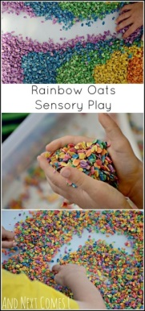
RAINBOW OATS: HOW TO DYE OATS FOR SENSORY PLAY
Dyeing the oats was very straightforward. Since we are passed the mouthing stage in our house, I went the non-edible route. However, you could easily make edible rainbow oats by using food colouring. To dye the oats, you will need:

6 cups of large flake whole grain oats (1 cup for each colour)
Water
Liquid watercolours or food colouring
Paper towel
In a bowl, I mixed approximately 1.5 tablespoons of water with a few drops of liquid watercolours (if you are using food colouring, you will need likely 8-10 drops depending on how vibrant you want them). You want just enough liquid to coat the oats. You do not want them to be drenched. I then added the rolled oats. Once all the oats were evenly coated, I dumped the mixture onto paper towel and left it in the sunroom to dry. Drying time was only about an hour.
Arrange the coloured oats into a rainbow.
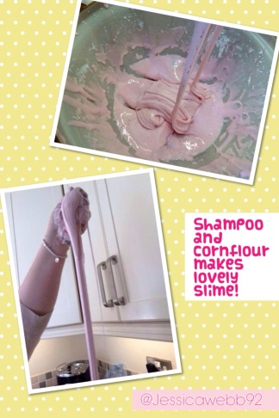
Soapy Sea Foam
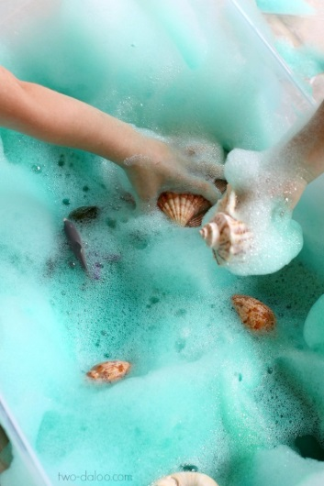 Soapy Sea Foam Recipe
1/3 cup water (I’ve read that distilled water yields the best bubbles, but our tap water did just fine)
1/3 cup Dawn dish soap (you can use whatever you have on hand)
1 tbsp cornstarch (cornflour in the UK)
A few squirts liquid watercolors in your desired color/colors (we used turquoise and green). I’ve also seen food coloring and Koolaid used to color soap foam, but beware of staining with both of those types of coloring. The liquid watercolors washed right out of our clothes and skin with no problems.
To create our foam, I simply combined all the ingredients above in the bowl of our KitchenAid stand mixer. If you don’t have one, no worries- you can use a hand mixer, blender, or even a food processor. Just mix equal parts of water and dish soap and then add a small amount of corn starch to act as a stabilizer. When I was testing the recipe the bubbles I made using cornstarch felt more dense and lasted much longer than those I made without, but if you don’t have any on hand it will still work.
Turn your mixing apparatus on high and mix for a couple of minutes until your foam is nice and fluffy. Then scoop the foam into a large container (we used a clear plastic storage bin) and repeat until you have the desired amount. I made a couple batches of blue, a couple more of green, and some plain white and swirled them all together to suggest the waves of the ocean.
Shaving foam and powder paint mixing
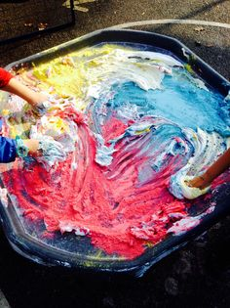
Ice Chalk
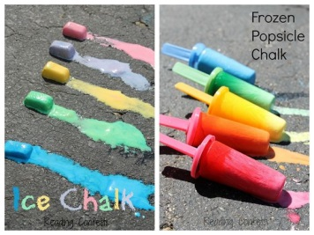
Marbled Paper Art
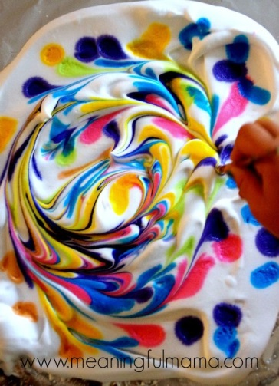
Materials Needed to Make Marbled Paper
* Affiliate links provided for your convenience. Anything you purchase through these links helps to support Meaningful Mama and the free resources I provide. Thank you for choosing to support us.
Shaving Cream
Food Coloring
Water
Heavier Weight White Paper
Straight Edge
Paint Brush
Muffin Tin
Medicine Dropper
Spatula
Tooth Picks or Spoon for Stirring Food Colouring
How you cover your table is up to you. I used a jelly roll pan lined with foil to house the shaving cream. I used a brown paper bag to lay the paper on afterward and scrape the shaving cream off. I also covered my table in a disposable plastic table cover that I use over and over again for art projects.
How to Make Marbled Paper with Shaving Cream
How to make marbled paper with shaving cream 1. Choose the colours of food colouring you want to use. I have a variety of gel colours because of my cake decorating, but you can use liquid food colouring as well. I used a muffin tin to sort the colours. I put a bit of colour in each one, added water to water it down a bit (about half way full in the tins) and then mixed it with a tooth pick.
2. I lined foil on a jelly roll pan for easy clean up. Let kids squirt out shaving cream onto the foil. Spread it out using a spatula. Make the layer about 1/2 inch thick and make it slightly larger than the size of your paper.
3. Using a medicine dropper, make drops of food colouring all over your shaving cream. Have a glass of water next to you, so the kids can clean out the dropper after each colour use.
4. Using a paint brush, kids can start twirling paint until desired swirl pattern. You want to encourage them not to over-mix, which will blend all the colours rather than having a nice swirl pattern.
5. Lay the paper down on the swirled shaving cream. Lightly press onto the shaving cream, making sure all the edges and corners are being exposed to the colour. Do not shift the paper, simple press straight down lightly. How to make marbled paper shaving cream
6. It is time for the magical moment. You will carefully lift the paper up. Don’t be disappointed. It looks like a mess of colourful shaving cream initially. Using a straight edge (We used a dish scraper), scrape of the shaving cream. Revealed underneath will be gorgeous marbled paper. Allow to dry.
Our marbled paper is beautiful and perfect for our art and schoolwork binders. I will add their initials or names with letter stickers. I will add the year as well.

Zebra Shaving Cream Activity
Shaving cream and black or grey paint – mix together to make a zebra effect.
Shaving Cream Rain
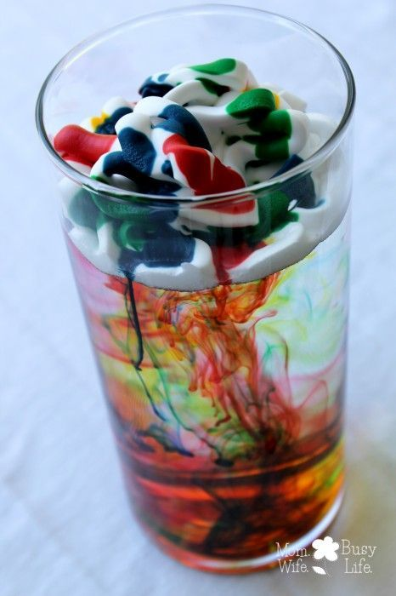
Regular Shaving Cream (not gel)
Food Colouring
Easy to see through glass (jar, cylinder, vase, drinking glass, pitcher, glass bowl)
Water
Directions:
Fill your glass about 75% full with water.
Shake the shaving cream well.
Spray a layer of shaving cream on top of the water until covered.
Drop two drops of each colour of food colouring on top of the shaving cream.
Watch the food colouring make it’s way slowly down into the water!
Add more food colouring as desired to create more rain!
The shaving cream serves as the cloud while the food colouring is the rain! You can just use blue for this experiment if you’d like, but I think it’s more fun to watch the different colours come together!

Rainbow shaving cream Art
